2B. Describe the purpose of this data mining report by doing the following:
1. Propose one question relevant to a real-world organizational situation that you will answer using one of the following clustering techniques:
• k-means
• hierarchical
Note: The implementation of k-means clustering requires the use of continuous variables only.
Can we group patients into distinct clusters based on their medical and demographic data to identify patterns that could help improve patient care and resource allocation?
2. Define one goal of the data analysis. Ensure your goal is reasonable within the scope of the selected scenario and is represented in the available data.
The goal is to segment patients into clusters based on their medical and demographic characteristics. This segmentation will help the hospital chain identify groups of patients with similar needs and develop targeted strategies to improve patient outcomes and optimize resource utilization.
C. Explain the reasons for your chosen clustering technique from part B1 by doing the following:
1. Explain how the clustering technique you chose analyzes the selected dataset. Include expected outcomes.
- k-means is a partition-based clustering technique that groups data points into k clusters by minimizing the variance within each cluster.
- It works by:
  - Randomly initializing k cluster centroids.
  - Assigning each data point to the nearest centroid.
  - Recomputing the centroids based on the mean of the points in each cluster.
  - Repeating the process until the centroids stabilize or a maximum number of iterations is reached.
Expected Outcomes:
- Patients will be grouped into clusters based on their similarities in continuous variables (e.g., age, vitamin D levels, total charges).
- Each cluster will represent a distinct group of patients with similar characteristics, which can be analyzed for actionable insights.

2. Summarize one assumption of the clustering technique.

k-means assumes that the data is continuous and that clusters are spherical and equally sized. It also assumes that the variance within each cluster is minimized.

3. List the packages or libraries you have chosen for Python or R, and justify how each item on the list supports the analysis.
pandas: For data manipulation and preprocessing.
- numpy: For numerical operations.
- scikit-learn: For implementing k-means clustering and determining the optimal number of clusters.
- matplotlib/seaborn: For visualizing the clusters.

D. Perform data preparation for the chosen dataset by doing the following:
1. Describe one data preprocessing goal relevant to the clustering technique from part B1.

The goal is to prepare the dataset by selecting only continuous variables, handling missing values, and scaling the data to ensure that all variables contribute equally to the clustering process.
2. Identify the initial dataset variables you will use to perform the analysis for the clustering question from part B1, and label each as continuous or categorical.
- Continuous Variables:
Age
  - VitD_levels
  - TotalCharge
  - Additional_charges
  - Doc_visits
  - Initial_days

3. Explain each of the steps used to prepare the data for the analysis. Identify the code segment for each step.
In cell 2, I handled the missing values, removed duplicated rows, selected continuous variables, scale the data, and I provided a copy of the cleaned dataset.

4. Provide a copy of the cleaned dataset. In attachments
E. Perform the data analysis and report on the results by doing the following:
1. Determine the optimal number of clusters in the dataset, and describe the method used to determine this number.
It would be 3 due to the elbow method.
F. Summarize your data analysis by doing the following:
1. Visualize the clusters and explain the quality of the clusters created. Include a screenshot of the cluster visualizations.
The quality of the clustering technique was evaluated using both the Elbow Method and the Silhouette Score.

The Elbow Method plot showed a clear "elbow" at k = 3, suggesting that three clusters is an appropriate choice for this dataset.
The quality of the clustering technique was evaluated using both the Elbow Method and the Silhouette Score. The Elbow Method identified k=3 as the optimal number of clusters, where the inertia curve bends significantly. The Silhouette Score for k=3 was calculated as 0.2509, indicating moderate clustering quality. While the clusters are somewhat distinct, there may be some overlap between data points in different clusters. This score supports the choice of k=3 as the optimal number of clusters
Additionally, the cluster visualization using PCA (Principal Component Analysis) shows that the clusters are well-separated in two-dimensional space, with minimal overlap between groups. This indicates that the k-means algorithm has effectively grouped patients with similar characteristics together.
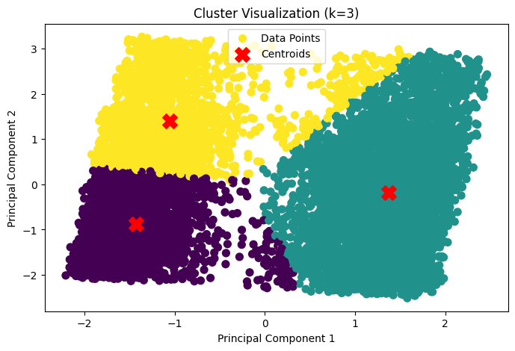
2. Discuss the results and implications of your clustering analysis.
Cluster 0:

Age: 37.44
Represents younger patients.
VitD_levels: 17.93
Slightly lower vitamin D levels compared to other clusters.
TotalCharge: 3288.16
Moderate healthcare charges.
Additional_charges: 8408.78
Lower additional charges compared to other clusters.
Doc_visits: 4.99
Moderate number of doctor visits.
Initial_days: 9.99
Short initial hospital stays.
Implications:
Cluster 0 likely represents younger patients with moderate healthcare needs and shorter hospital stays. These patients may benefit from preventive care programs to reduce future healthcare costs.

Cluster 1:

Age: 53.43
Represents middle-aged patients.
VitD_levels: 17.95
Similar vitamin D levels to Cluster 0.
TotalCharge: 7440.23
High healthcare charges.
Additional_charges: 12726.44
Moderate additional charges.
Doc_visits: 4.99
Similar number of doctor visits as Cluster 0.
Initial_days: 60.41
Long initial hospital stays.
Implications:
Cluster 1 likely represents middle-aged patients with significant healthcare needs and longer hospital stays. These patients may benefit from targeted interventions to manage chronic conditions and reduce hospital stays.

Cluster 2:

Age: 72.48
Represents older patients.
VitD_levels: 18.03
Slightly higher vitamin D levels compared to other clusters.
TotalCharge: 3458.44
Moderate healthcare charges.
Additional_charges: 18644.06
High additional charges.
Doc_visits: 5.07
Slightly higher number of doctor visits.
Initial_days: 11.57
Moderate initial hospital stays.
Implications:
Cluster 2 likely represents older patients with moderate healthcare charges but high additional charges. These patients may benefit from specialized care programs to address age-related health issues and reduce additional charges.

Results and Implications
Cluster Characteristics:

Cluster 0: Younger patients with moderate healthcare needs.
Cluster 1: Middle-aged patients with significant healthcare needs.
Cluster 2: Older patients with specialized healthcare needs.
Healthcare Strategies:

Cluster 0: Focus on preventive care and wellness programs to reduce future healthcare costs.
Cluster 1: Develop chronic disease management programs to reduce hospital stays and healthcare charges.
Cluster 2: Offer specialized care for age-related health issues and optimize additional charges.

3. Discuss one limitation of your data analysis.
A limitation of this analysis is that k-means clustering assumes clusters are spherical and equally sized, which may not reflect the true structure of patient populations. Additionally, PCA reduces dimensionality for visualization but may obscure some feature relationships.
4. Recommend a course of action for the real-world organizational situation from part B1 based on the results and implications discussed in part F2.
Cluster 0 (Younger Patients):

Implement preventive care programs such as health education, fitness initiatives, and regular check-ups to reduce future healthcare costs.
Offer digital health tools (e.g., mobile apps) to engage younger patients in managing their health.
Cluster 1 (Middle-Aged Patients):

Develop chronic disease management programs to address conditions like diabetes, hypertension, and cardiovascular diseases.
Provide telemedicine services to reduce the need for frequent hospital visits and manage conditions remotely.
Cluster 2 (Older Patients):

Offer specialized care programs for age-related health issues, such as geriatric care, physical therapy, and mental health support.
Optimize additional charges by streamlining services and offering bundled care packages for older patients.
No sources were used.

